WELCOME TO MYPORTAL.MD!

- * When using the patient portal, please do NOT use Internet Explorer or any mobile devices, such as a cell phone or tablet – Internet Explorer is not HIPAA compliant and you may not be able to view all features of the portal with a mobile device. A desktop or laptop would work best. If you would like to use the patient portal on a mobile device – please be sure to download the “My Portal MD” app.

- In order to Register your New Account to the Patient Portal:
- Please go to the Registration e-mail sent to your Inbox and click on the “Please click here to register” link.
- If you have given your cell phone number to the clinic, you will see this box at the top and this information will be required before creating a new account.
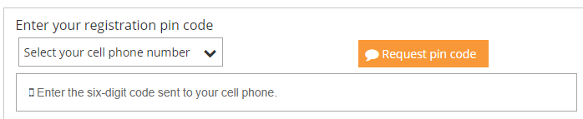
Please click on the “Select your cell phone number” drop down and select the number that matches that last four of your cell phone number. Once selected, click on the “Request pin code” button and enter in the six-digit code sent to your cell phone number.
3. When entering in your first name and last name, be sure to fill out exactly what the clinic has for each field for your patient chart. This can include/exclude spaces, hyphenations, apostrophes, etc.
4. When creating a password, the password must contain at least 8 characters, one letter, one number, one capitalization, and one special character – the special character CANNOT be a punctuation or an asterisk (! . , *) – please try to use characters, such @, #, $ - a good example is Password$1
5. Once all of the fields are filled out, click on Create New Account and then enter in your Username and Password into the Log-In screen.

- If you have used your e-mail address previously with the patient portal:
1. Please go to the Registration e-mail sent to your Inbox and click on the “Please click here if you already have a username and password” link.

2. Click on the “Forgotten Account?” link.

3. If you have given your cell phone number to the clinic and registered using a pin code, you can enter your phone number in order to Retrieve your Username or Password. If not, you can use your e-mail address.

